ECMAScript 6 introduces a new keyword to declare variables: let. Unlike variables declared with var that are function-scoped, variables declared with let are block-scoped: they only exist in the block they are defined in.

1. In your code editor, open js/main.js and examine the calculateMonthlyPayment function:

var calculateMonthlyPayment = function(principal, years, rate) {

if (rate) {

var monthlyRate = rate / 100 / 12;

}

var monthlyPayment = principal * monthlyRate /

(1 - (Math.pow(1/(1 + monthlyRate), years * 12)));

return monthlyPayment;

};

Notice that on line 5, the monthlyRate variable is available even though it was declared within the if block. This is because variables declared with var are **function-scoped**, and not **block-scoped**. This way of declaring and using variables is definitely not a best practice: it is used here to illustrate the difference between function-scoped and block-scoped variables.

To keep the code simple and readable, the field validation used in this sample application is intentionally simplistic and incomplete.

1. Replace all the occurrences of var with let. **Don’t change anything else yet**. main.js now includes ECMAScript 6 code and will no longer work in ECMAScript 5 browsers.
2. On the command line, type the following command to run the **babel** script and compile main.js to ECMAScript 5:

npm run babel

1. Open a browser, access [http://localhost:8080](http://localhost:8080/), and click the **Calculate** button: **it doesn’t work**. Open the developer console. You should see a message similar to this:

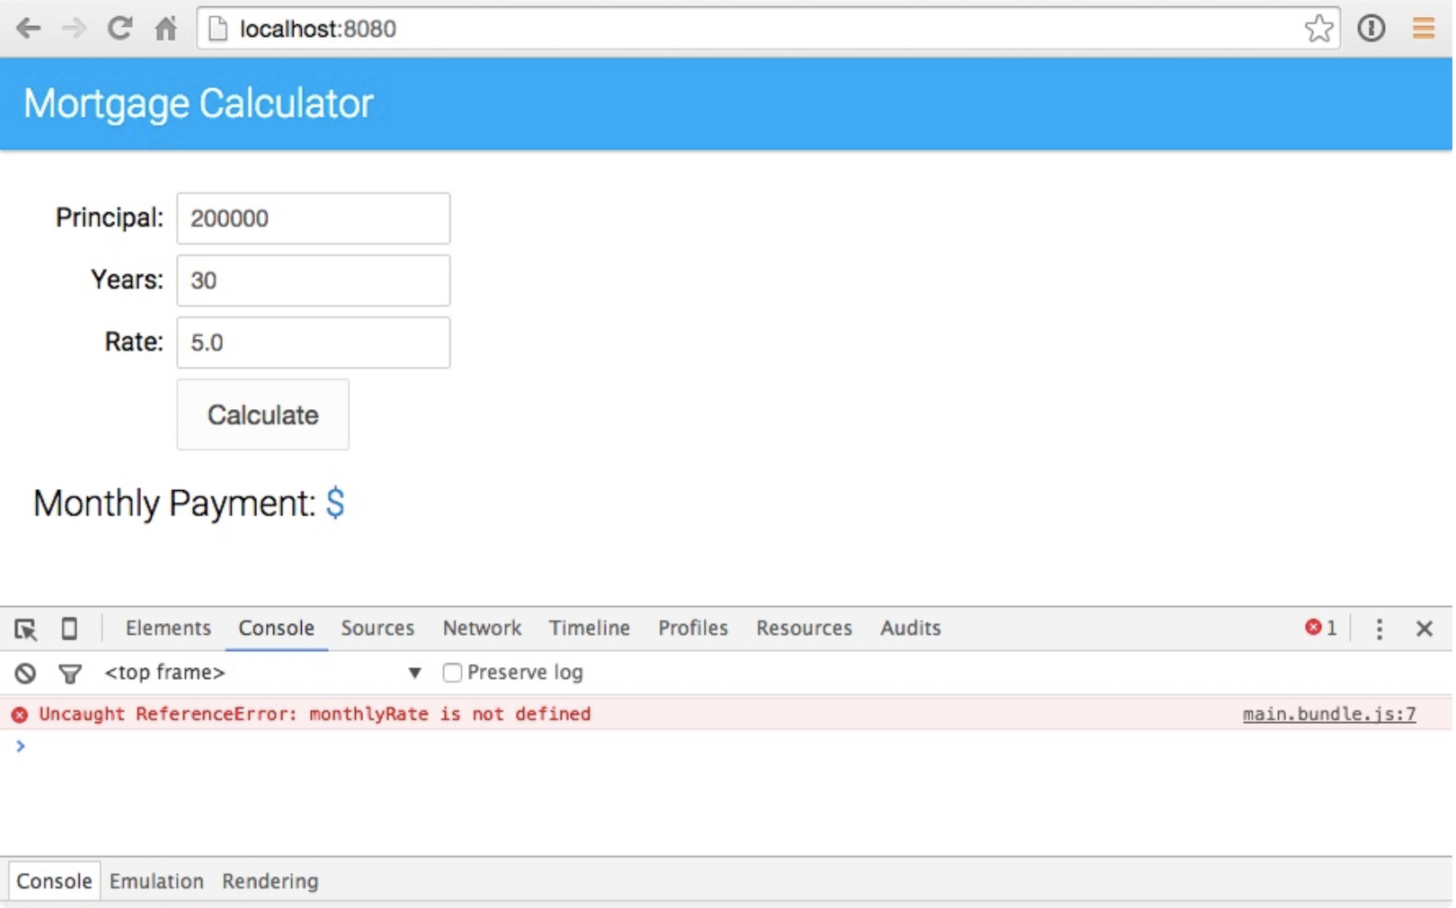

This is because unlike var variables which are **function-scoped**, let variables are **block-scoped**: they only exist in the block they are defined in.

1. In main.js, modify the calculateMonthlyPayment function as follows:

let calculateMonthlyPayment = function(principal, years, rate) {

let monthlyRate = 0;

if (rate) {

monthlyRate = rate / 100 / 12;

}

let monthlyPayment = principal * monthlyRate /

(1 - (Math.pow(1/(1 + monthlyRate), years * 12)));

return monthlyPayment;

};

1. On the command line, type the following command to rebuild the application:

npm run babel

1. Open a browser, access [http://localhost:8080](http://localhost:8080/), and click the **Calculate** button: you should now see the monthly payment.

If you are still seeing the error, make sure you clear your browser’s cache and refresh the page.